Object description
AUCTION: Licensing or sale of intellectual property created as a result of research at the Rēzekne Technology Academy (RTA) takes place in accordance with Article ^{39.5} of the Law on Scientific Activities .
RTA announces a written auction of intellectual property, which consists of one know-how - the design and technology of " Stepless transmission for micromobility vehicles".
SUMMARY OF THE INVENTION:
The object of the auction: consists of one piece of know-how – (" Stepless transmission for micromobility vehicles", according to Latvian patent application No. LVP2021000074 and international patent application No. PCT/LV2022/050006 under the name "STEPLESS BELT TRANSMISSION", which was created by the operational program "Growth and employment ” 1.2.1 of the specific support objective “Increase private sector investments” R&D 1.2.1.2 of the measure “Support for the improvement of the technology transfer system” within the project No. KC-PI-2020/62), hereinafter – intellectual property (IP). The intellectual property is for technology development in electric micromobility vehicles with stepless transmission.
The science description includes new and unpublished methods, parts description, electrical schematics, and program codes for a continuously variable transmission system for micromobility vehicles. The system consists of seven parts: microcontroller automated control, electric belt tensioner, drive pulley - variator , driven toothed pulley , toothed V-belt, bracket and chassis fasteners. Science contains detailed descriptions, schematics, drawings and program codes.
More detailed information about the invention and initial commercialization strategy can be provided
by the project coordinator: Antons Pacejs, Antons.Pacejs@rta.lv .
•Price range: according to the applicant's offer;
•Keywords: stepless transmission, electric micromobility , electric transport;
•The research was carried out by: Rēzekne Academy of Technology engineering team;
•Contact phone: +371 29866371 (Antons Paceys);
•Contact e-mail: Antons.Pacejs@rta.lv .
SUMMARY:
The invention relates to a stepless belt transmission. A continuously variable belt drive comprises a first shaft; the second shaft; an adjustable V-belt pulley mounted on the first shaft and capable of changing the diameter of the belt contact depending on the revolutions under the influence of centrifugal forces. The transmission includes a toothed pulley attached to the second shaft and a toothed V-belt positioned on the adjustable V-belt pulley and the driven toothed pulley to transmit power from the V-belt pulley to the toothed pulley. The transmission additionally includes a belt tensioner that is located between the V-belt pulley and the toothed pulley. The belt tensioner comprises two tensioning rollers positioned against each other and the outer flanges of the toothed V-belt so that the tensioning rollers can apply force to the toothed V-belt from both sides thereof, tensioning said V-belt.
PRODUCT OF THE INVENTION: technology and its description " Stepless transmission for micromobility vehicles".
A brief description of the main components of IP
1. Drive pulley (see Fig. 1)
Comet 103HPQ primary pulley suitable for 32 mm wide V-belts with a contact diameter of 85-125 mm.
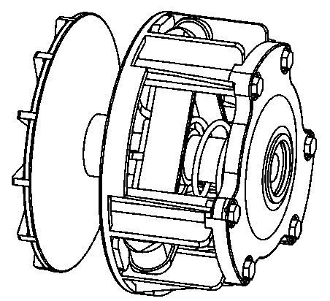
Fig. 1 Drive pulley.
2. Driven vertebra (see Fig. 2)
Specially designed pulley suitable for 50 mm axle.

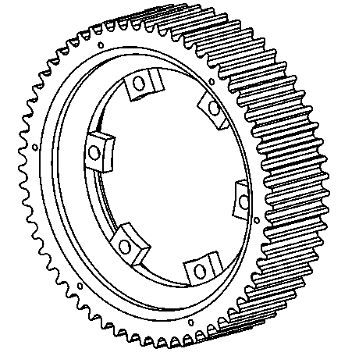
Fig. 2 Driven vertebra.
3. Tensioner (see Fig. 3)
Automatic belt tensioner with robust construction, powered by a closed-loop stepper motor with 8 Nm holding torque.
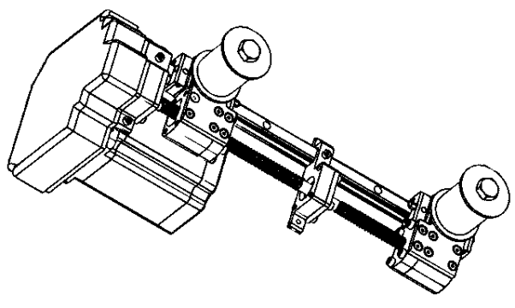
Fig. 3 Tensioner.

4. Strap (see Fig. 4)
Dayco XTX is specifically designed to maximize performance in snowmobile drive systems. Specially developed high temperature polymer combined with the highest level of engineering reinforcement compatible with IP.
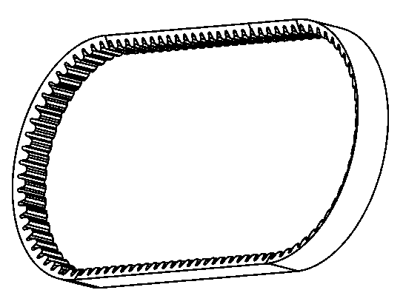
Fig. 4 Strap.

5. Bracket (see Fig. 5)
Laser cut , bent and welded bracket for use with bolt spacing for ME1507 PMSM motor and Sevcon GEN 4 size controller.
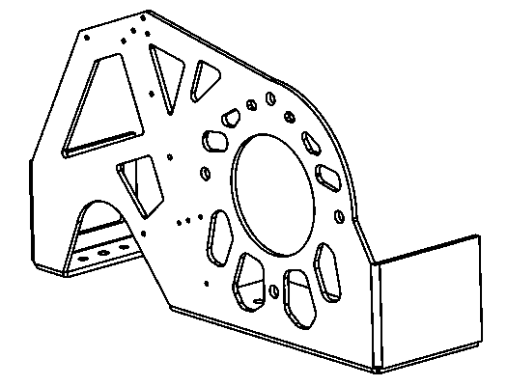
Fig. 5 Bracket .

6. Chassis fasteners (see Fig. 6)
Made for Gillard size chassis used in electric racing karts.
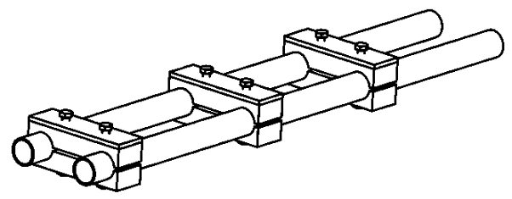
Fig. 6 Chassis mounts.

See figure 7 for the summary .

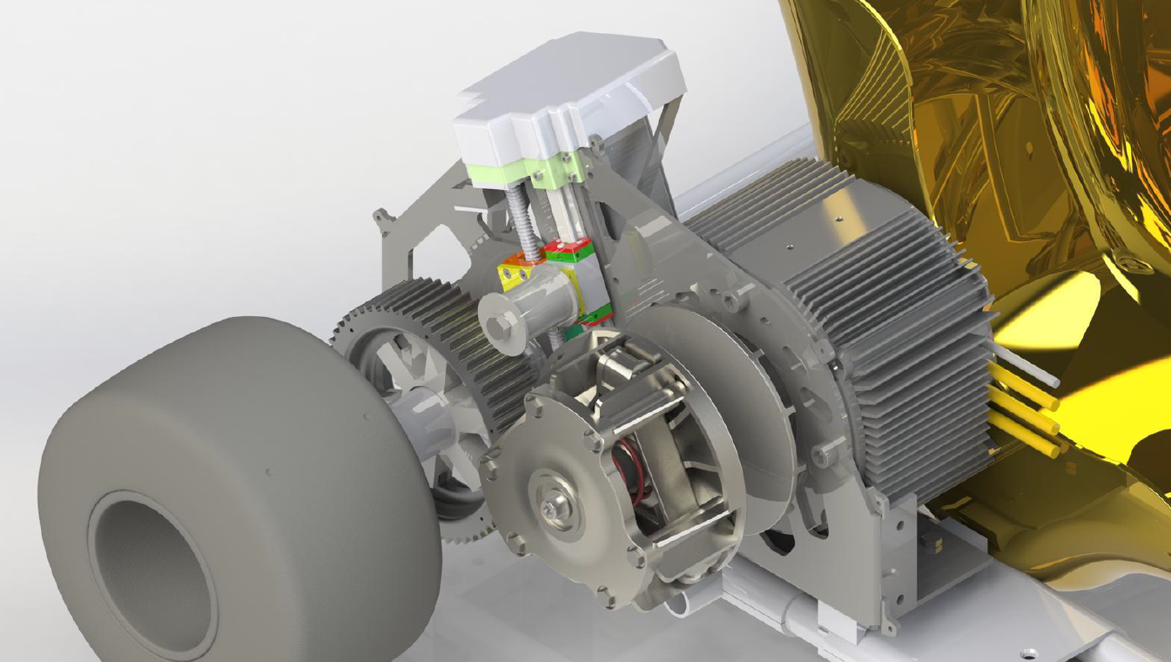
Fig. 7 Total .
FIELD: The invention relates to a stepless belt drive.
OBJECTIVE AND PURPOSE OF THE INVENTION: The objective of the invention is to increase efficiency, starting torque and maximum speed in electric micromobility vehicles.
Disadvantages of other equivalent devices:
- gears take place in steps (steps);
- gears usually consist of at least two mechanical gears with torque breaks;
- variator 's primary pulley and gear pulley are not used together, without additional gears.
Common features with other methods and devices:
(a) are systems that use a rubber belt drive;
b) are systems that use a variator as a drive pulley.
INTELLECTUAL PROPERTY PROTECTION:
The science description includes new and unpublished methods, parts description, electrical schematics, and program codes for a continuously variable transmission system for micromobility vehicles. The system consists of seven parts: microcontroller automated control, electric belt tensioner, drive pulley - variator , driven toothed pulley , toothed V-belt, bracket and chassis fasteners. Science contains detailed descriptions, schematics, drawings and program codes.
ADDITIONAL INFORMATION:
•Product – continuously variable transmission for micromobility vehicles; Cost
•of mass production of one product : starting from 1200 euros.
INTELLECTUAL PROPERTY DOCUMENTATION, which includes :
Intellectual property development description, technical documentation, electrical schematics, drawings, program codes and supporting documentation.

